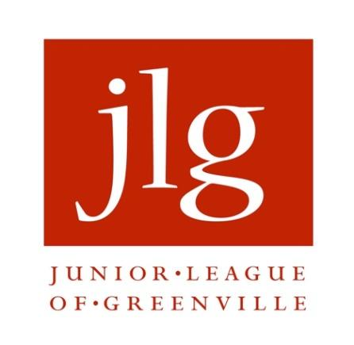

FOR IMMEDIATE RELEASE: Contact:
February 8, 2019 Kate Hudson, Senior Writer, VISIONS | 864-704-7834
Katie Beliles, Media Specialist | 949-872-0504

Junior League of Greenville’s 2019 Young Women’s Writing Contest
Now Open for Entries

GREENVILLE, S.C.--The Junior League of Greenville (JLG) is now accepting entries for its seventh annual Young Women’s Writing Contest. The contest is open to all female students in Greenville County public, private and home school programs in grades 6 through 12.

The winner of the 2019 Young Women’s Writing Contest will be announced on May 1, 2019. Along with a $500 scholarship award, the winning essay will be published in the Summer 2019 issue of VISIONS magazine, and the winner will be invited to accept her award at the JLG's Annual Meeting held on May 14, 2019. VISIONS, the Junior League of Greenville’s signature magazine, is published twice yearly and reaches an audience of over 4,500 readers.

The Junior League of Greenville invites interested candidates to write an essay in response to the following topic:

Over the past several issues, Teen Vogue has received a lot of attention for covering topics outside its traditional commentary on fashion and pop culture with articles on politics, activism, and current events. Regardless of where you stand on the issues covered, we'll bet you also are engaged with the world around you beyond Instagram trends and celebrity couples. As a young woman in 2019, what issue do you care about the most and how are you using your voice to elevate that cause?

Essays should be between 750-1,200 words and will be accepted until Wednesday, March 20, 2019. They may be submitted via email to VISIONS@jlgreenville.org.

For more information, please visit www.jlgreenville.org.

About Junior League of Greenville
The Junior League of Greenville is an organization of women committed to promoting volunteerism, developing the potential of women, and improving the community through the effective action and leadership of trained volunteers. Its purpose is exclusively educational and charitable. The Junior League of Greenville initiates and participates in programs and partnerships that improve the economic mobility of women and reduce human trafficking in Upstate community. For more information about the Junior League of Greenville, please visit www.jlgreenville.org.

# # #

